Lacus Clyne

Appearing in both Gundam SEED and Gundam SEED Destiny, she is a Coordinator and one of the lead females in both series. In the PLANTs she works as a singer however her songs and words have a great influence. She later then joins the Archangel to form the three-ship alliance to stop the 1st Alliance-PLANT war. In Gundam SEED Destiny, she becomes the head of the Clyne faction and a important character in the stopping of the 2nd Alliance-PLANT war.

Background

She first appears after Kira Yamato saves her from a drifting life pod in space. We then learn that she is Athrun Zala’s fiancée and that she is the daughter of PLANT Supreme Council Chairman Siegel Clyne. Being the daughter of the Chairman of the PLANT Supreme Chairman, she herself has a great deal of influence over the people of the PLANTs.

Bearing the family name of Clyne, Lacus has been shown to have a lot of access to Military bases and Hangers. Examples of the power she gains from her name, words and songs can be seen when she gives The Freedom to Kira Yamato.

Personality

Lacus Clyne is kind and demure, but also a brave and strong-willed woman. In Gundam SEED Destiny Lacus Clyne can be seen as more of the demure type. When her father was still alive, she was still uncertain as to what her role was regarding the 1st Alliance-PLANT war.

Lacus is can also be insightful, compassionate and sensitive. During Gundam SEED, after she meets Kira Yamato, she has provided compassion to Kira Yamato during the times when the bitterness and death of war was too much for him.

“I’ll be alright... because I swore I’d never cry again.” – Kira Yamato to Lacus Clyne

“It’s ok to cry. You should cry, while we’re still able to.” – Lacus Clyne to Kira Yamato

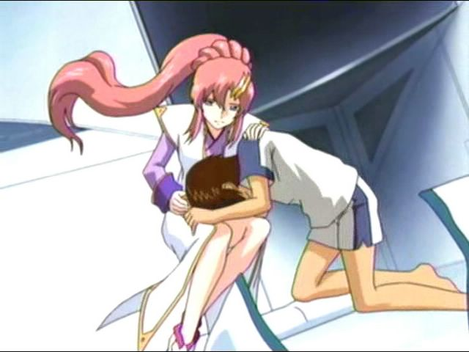

In Gundam SEED, we can see Lacus Clyne’s character develop gradually. After her father died, we can see Lacus Clyne becoming more and more strong-willed, standing for what she believes in and preaching her belief to the people of the PLANTs.

Her father’s death also made her more insightful as she now sees the war differently compared to how she was during the early parts of Gundam SEED.

“Why? Even if you go you can’t end the war by yourself.” – Lacus Clyne to Kira Yamato

Lacus Clyne said this to a recovered Kira Yamato who wanted to go back to Earth, go back to the war. If you compare that Lacus Clyne to the Lacus Clyne in the further episodes of Gundam SEED, there is a clear difference in the will and insight between them.

“What is it you believe in? What is it you are fighting for? Is it for that medal you received? Or for your father’s orders? Lacus Clyne to Athrun Zala.

Abilities

Relationships

Athrun Zala

Kira Yamato

Why did Lacus Clyne choose Kira Yamato?

Cagalli Yula Attha

Andrew Waltfeld

Meer Campbell